Roll No.:2503a52531
Name:B.Poojitha
Batch:18
Question 3. Student Query Routing System
Scenario:
A university chatbot must route student queries to Admissions, Exams,
Academics, or Placements.
Tasks:
1. Create 6 sample student queries mapped to departments.
2. Implement Zero-shot intent classification using an LLM.
3. Improve results using One-shot prompting.
4. Further refine results using Few-shot prompting.
5. Analyze how contextual examples affect classification accuracy.

Prompt for ZERO-SHOT:
Classify the following student query into exactly one department:
Admissions
Exams
Academics
Placements
Admissions: Questions about admission, application, and required documents.
Exams: Questions about examinations, exam timetable, and exam registration.
Academics: Questions about courses, attendance, subjects, and academic rules.
Placements: Questions about jobs, internships, and campus placements.
Student Query:
{query}
Return only the department name.

Code for ZERO-SHOT:
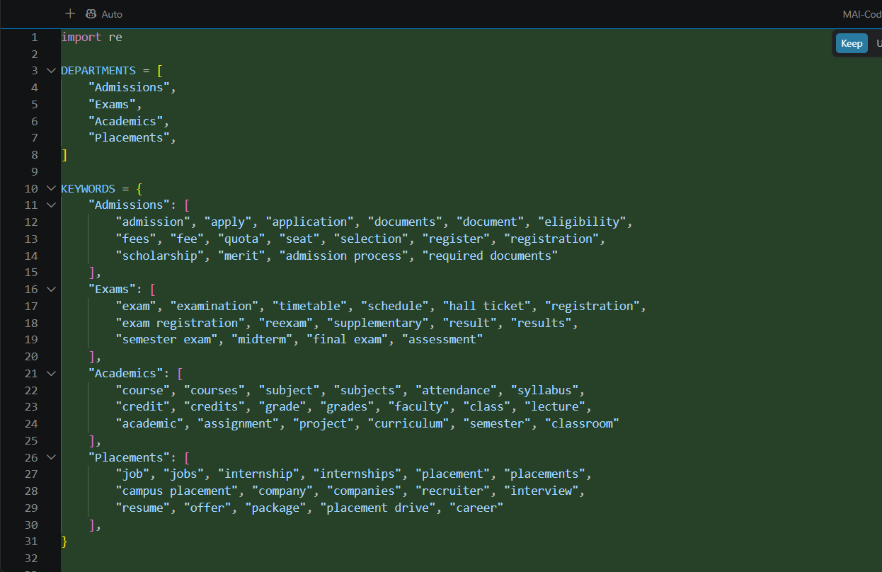
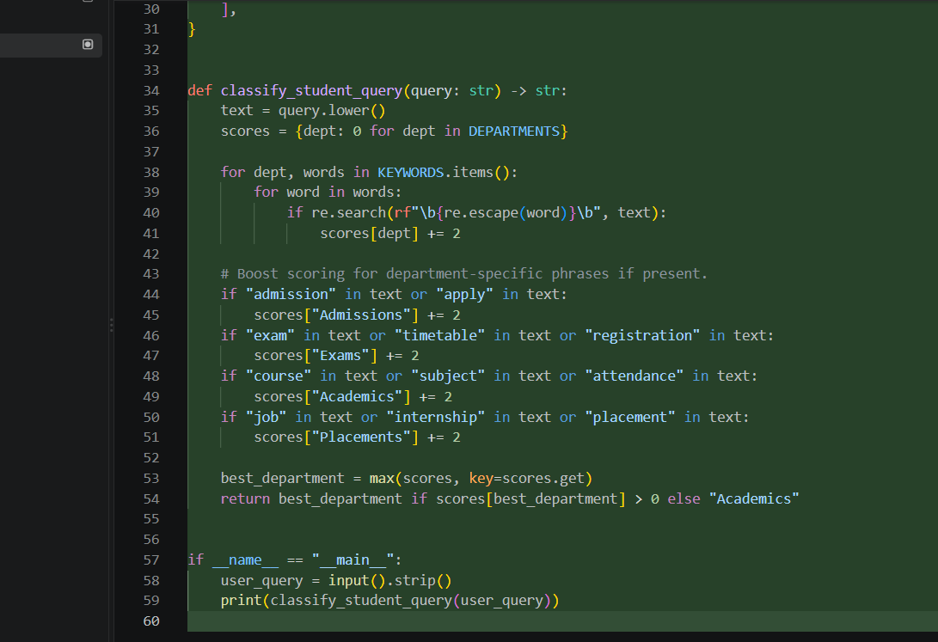

Output:
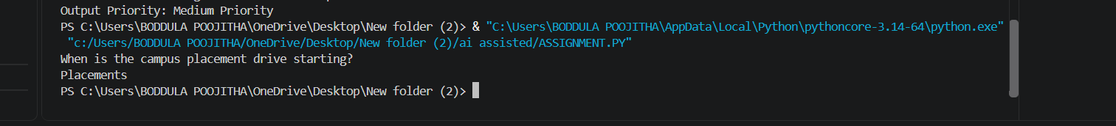

Prompt for ONE-SHOT:
Classify the student query into Admissions, Exams, Academics, or Placements.
Example:
Student Query: How can I apply for admission?
Department: Admissions
Now classify:
Student Query:
{query}
Return only the department name.
Code for ONE-SHOT:
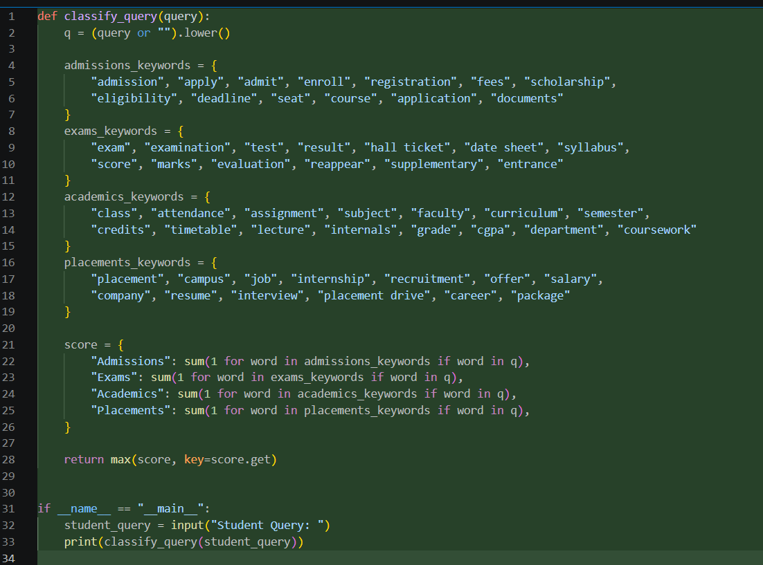
Output:
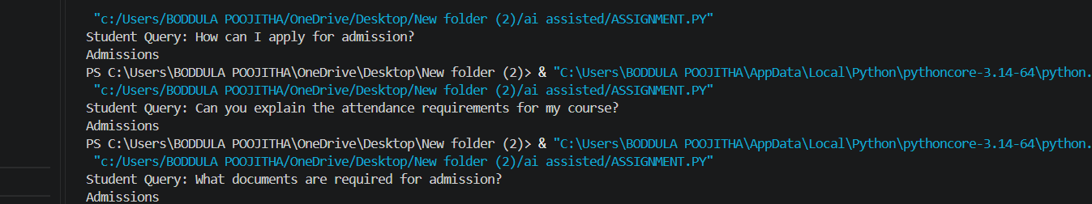

Prompt for FEW-SHOT:
Classify student queries into Admissions, Exams, Academics, or Placements.
Example 1:
Query: How can I apply for admission?
Department: Admissions
Example 2:
Query: When will the semester exam timetable be released?
Department: Exams
Example 3:
Query: Can you explain the attendance requirements?
Department: Academics
Example 4:
Query: When is the campus placement drive starting?
Department: Placements
Now classify:
Query:
{query}
Return only the department name.

Code for FEW-SHOT:
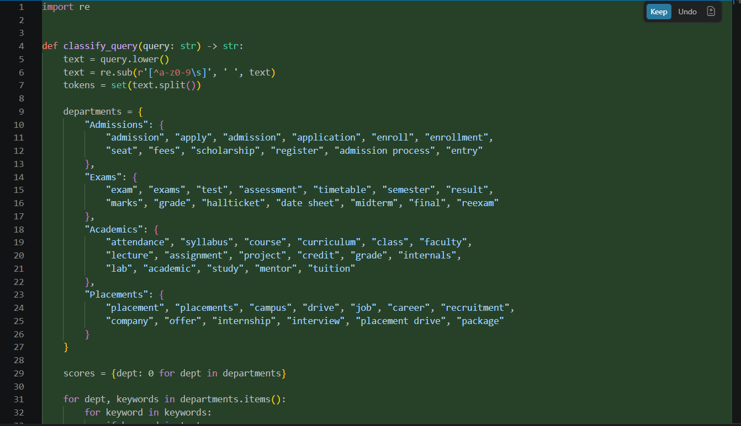
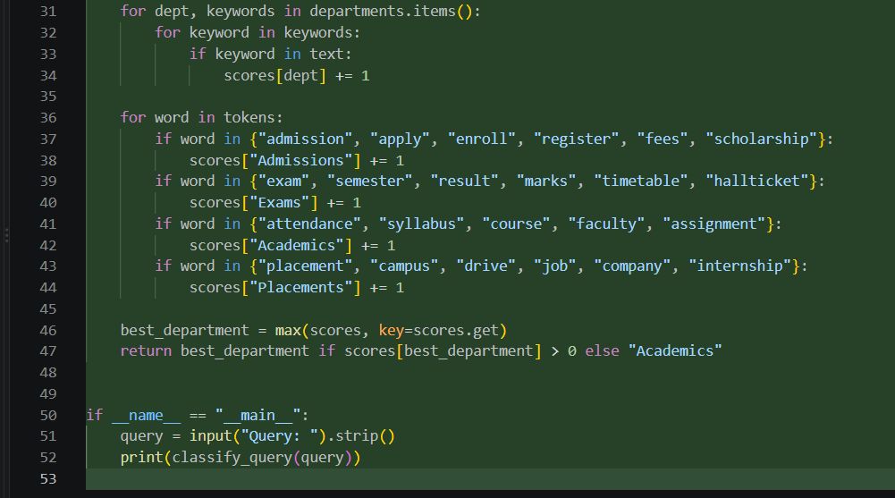
Output:
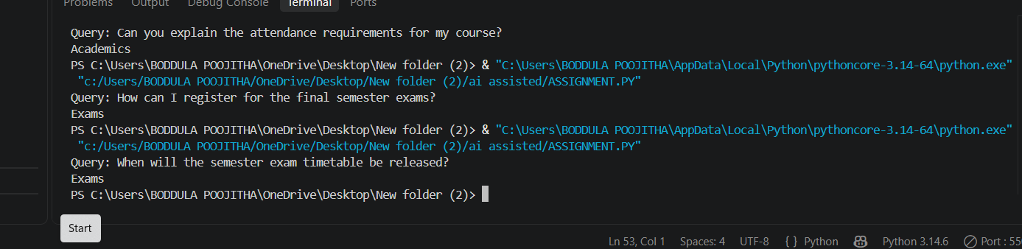
Observations:
1. Zero-shot prompting can classify simple student queries without providing examples.
2. It may face difficulty when a query is ambiguous or contains multiple keywords.
3. One-shot prompting gives one example, helping the model understand the expected classification format.
4. Few-shot prompting provides examples from multiple departments, making classification more accurate and consistent.
5. Queries related to admission, exams, academics, and placements can be clearly separated using suitable examples.
6. Few-shot prompting is especially useful when different queries have similar wording but different meanings.

